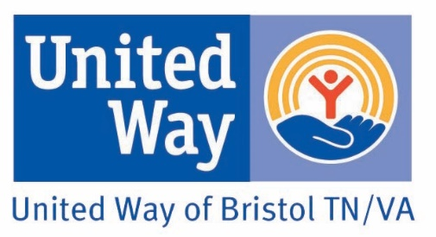
The mission of the United Way of Bristol TN-VA is to bring together resources to help people in our community live healthy, productive lives. The United Way of Bristol helps support over 40 programs in our communities through our partner agencies and initiatives. We also offer a meeting place for our partner agencies and other community groups at no charge.

For more information call 423-968-4912 or visit us at www.unitedwaybristol.org

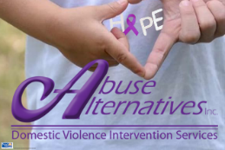 | 423.652.9093  Abuse Alternatives provides 24-hour hotline, emergency shelter, and outreach services to victims and children of domestic violence and batterers intervention program to perpetrators of domestic violence. |  | 423.878.1600  Frontier Industries, a division of Frontier Health provides programs that improve the overall quality of life for people with disabilities by providing residential services, extensive vocational training for people with disabilities who have limited or no previous work history, and assistance/support in community employment.
 | 423.765.2000  American Red Cross of NE TN provides programs to help prevent, prepare for and respond to life-threatening emergencies. | 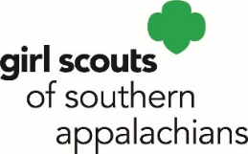 | 423.929.8185  Girl Scouts of the Southern Appalachians provides programs that build girls of courage, confidence, and character, who make the world a better place.
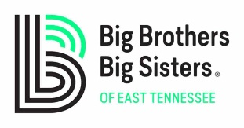 | 423.247.3240  Big Brothers Big Sisters helps children overcome adversity and achieve educational success, higher aspirations, greater confidence, better confidence and avoidance of risky behaviors through one-to-one mentoring. | 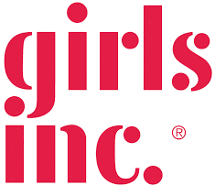 | 276.669.8686  Girls Inc. provides services to girls ages 5-18 with nationally recognized afterschool and summer programs; we inspire girls to be STRONG, SMART and BOLD.
 | 276.699.8932  Boys and Girls Club of the Mountain Empire provides programs to inspire and enable all young people, especially those who need us most, to realize their full potential as productive, caring, responsible citizens. | 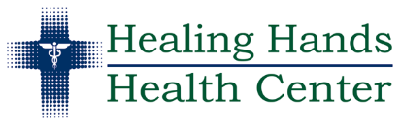 | 423-652-0260  Healing Hands Health Center provides charitable health clinic services including medical, dental, chiropractic, podiatry, counseling, and eye care to the working uninsured, low-income persons and their families of the Greater Bristol area.
 | 276.466.8292  Bristol Faith in Action provides financial assistance to households needing emergency help with food, housing, essential utilities and prescriptions. An ecumenical outreach mission. | 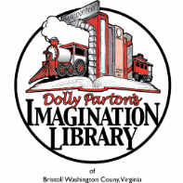 | 276.676.6222  Imagination Library of Bristol VA provides free books to children from birth through their 5th birthday at no cost to the family. The program is free to all children residing in Bristol Virginia regardless of the family’s income.
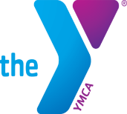 | 423.968.3133  The YMCA Bristol’s focus is on youth development, healthy lifestyles, and social responsibility. Through a wide range of relationship-focused, impactful programs, services, partnerships, and collaborations, we offer hope throughout the community. |  | 423.288.1828  Link House, a division of Frontier Health provides food, shelter, crisis intervention, diagnostic and evaluation services to adolescents who are neglected, abused, runaway, throwaway, unruly or delinquent.
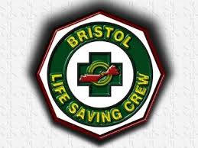 | 276.669.5441  Bristol Life Saving Crew provides the best quality in emergency medical services to Bristol Virginia and surrounding area. | 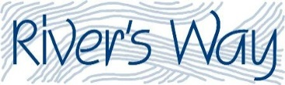 | 423.538.0405  River’s Way provides outdoor adventure programming for youth-at-risk and youth with disabilities in Bristol and surrounding communities.
 | 423.989.4500  Bristol Regional Counseling Center, a division of Frontier Health provides counseling, case management, alcohol and drug treatment and psychiatric services to adults and children. A fully accredited mental health service center. | 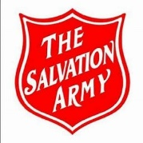 | 423.764.6156  Salvation Army Bristol provides ongoing emergency assistance for individuals and/or families that are in need of shelter, meals, rent, utilities, medication, food, local transportation and other services essential for achieving independent living.
 | 276-669-6331  Bristol Regional Speech and Hearing Center provides comprehensive and quality speech, language, and hearing services encompassing prevention, promotion, identification, intervention and education. | 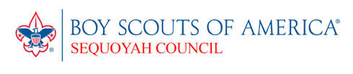 | 423-952-6961  Sequoyah Council Boys Scouts of America provides programs emphasizing character development and values-based leadership training and is the nation’s foremost youth program.
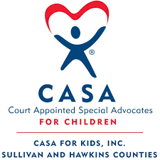 | 423.247.1161  CASA for Kids provides professionally trained and supervised Court Appointed Special Advocates for abused/neglected children coming to the attention of juvenile court, so these children can more quickly end up in safe, permanent homes. | 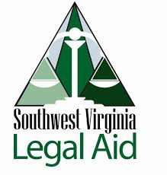 | 888.201.2772  Southwest Virginia Legal Aid Society provides free legal services to low-income residents of Southwestern Virginia, helping with problems that most seriously affect their lives: safety (domestic violence), housing, health, income or family stability.
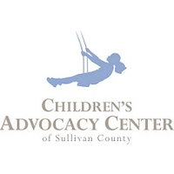 | 423.279.1222  Children’s Advocacy Center of Sullivan County provides programs to combat child sexual and severe physical abuse by coordinating and providing services to children and families in crisis in a safe, caring environment. | 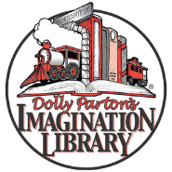 | 423.239.1100  Sullivan County Imagination Library develops the love of reading in all children in Sullivan County by providing an age-appropriate book each month to every child from birth to five years.
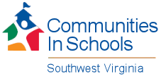 | 276.821.5630  CIS of SWVA surrounds students with a community of support, empowering them to stay in school and achieve in life. | 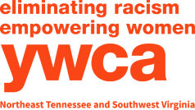 | 423.968.9444  YWCA NETN & SWVA is dedicated to eliminating racism, empowering women and promoting peace, justice, freedom, and dignity for all.
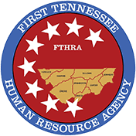 | 423.461.8200  First Tennessee Human Resource Agency Supportive services provides protective supervision and care for adults in their own home. Teaching homemaker skills; provision of household management; essential shopping; household tasks; provision of personal care; and/or provision of temporary care to help the adult return to or remain in his/her own home. |  | 423-444-0622 x700  Bristol Connect is a program of Bristol’s Promise in partnership with the United Way of Bristol that connects workers with personalized resources and ongoing support so life challenges don’t keep them from bringing their best selves to work.

OTHER COMMUNITY PARTNERSHIPS:
Bristol Emergency Food Pantry Upper East TN Human Development Agency People Incorporated
21 Washington Street - Bristol, VA Assists TN Residents Only with rent, utility Assists VA Residents Only with
Behind the Bristol Train Station assistance, commodoties and other a variety of resources.
Open Monday through Friday; 1-4 p.m. resources. 423-968-3951 1-833-429-7754

